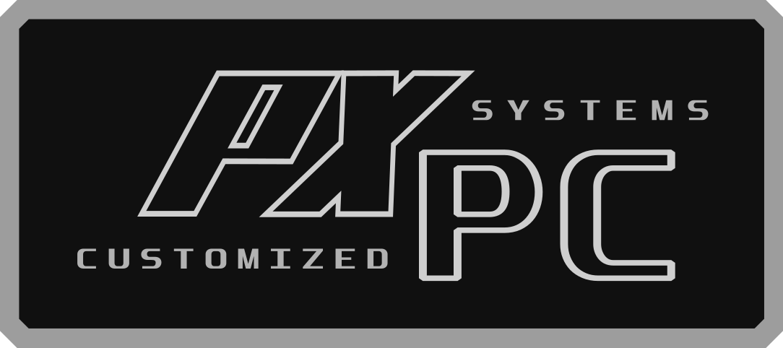

CERTIFICATE OF OWNERSHIP

Your specialized Pixl Pc machine has been hand-crafted with precision using industry’s finest components. This piece of high-end technology now separates You from the rest of humanity, and it ready to serve you for the rest of its life.
- Pixl Pc Team -


192901
Packaging Number

YOUR MACHINE DETAIL

Chassis Model : Cube Gaming Klassis
Processor : Intel Core™ i5 9600K Six-Core 3,7-4,6 GHz 9MB Chace
Chipset : Intel Z390
Motherboard : AsRock Z390 Phantom Gaming 4
Memory : DDR4 4x 8GB 3200Mhz Dual-Channel Tsunami X RGB
Power Supply : 600W 80+ Bronze Certified
Graphic Card : Nvidia GeForce RTX 2060 6GB GDDR6
Hard Drive Set 1 : SSD 512GB Adata SU750
Hard Drive Set 2 : WD Caviar Blue 1TB
Optical Drive : - no thanks
Internet Access : Gigabit LAN & TpLink WiFi Adapter
Sound Card : OnBoard Realtek ALC892 8 CH HD Audio w/ ELNA Audio Caps
CPU Cooling System : Liquid Cooler with 120mm Radiator RGB
GPU Cooling System : Air Cooling Dual Fan
CPU Boost : Intel Factor Boost 4,6Ghz
Memory Boost : XMP 3200mhz
Graphics Boost : Factory Boost 1680Mhz
Operating System : Win 10 Pro 64bit
Virus Protection : Build in Windows Firewall
Office : Ms. Office 2013
Monitor : - no thanks
Keyboard : - no thanks
Mouse : - no thanks
Speaker : - no thanks
Other Gear : - no thanks

